Degenerate Triangle

Definition
# Source: AI Source: Provided by: [Data Path: Persons Table -> ID Column: 1, Name_En Column: Motasem Essam] -> From: [ChatGPT] on [7/25/2026]
A Degenerate Triangle is a limiting case of a triangle in which all three vertices lie on the same straight line, causing the triangle to have zero area.
For three points $A$, $B$, and $C$to form a degenerate triangle, they must be collinear, and their side lengths must satisfy the triangle inequality with equality for one side.
For example, if:
$$AB=3, BC=5, AC=8$$
then:
$$AB+BC=AC$$
The three points can lie on one straight line, with $B$between $A$and $C$.
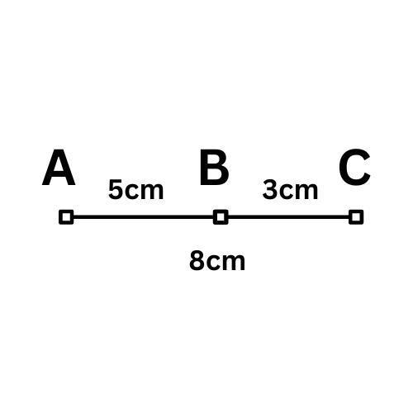

Simple Definition
# Source: AI Source: Provided by: [Data Path: Persons Table -> ID Column: 1, Name_En Column: Motasem Essam] -> From: [ChatGPT] on [7/25/2026]
A degenerate triangle is a limiting triangle whose three vertices lie on a straight line and whose area is zero.
Important distinction: In ordinary Euclidean geometry, a triangle must have positive area and three non-collinear vertices. Therefore, a degenerate triangle is not a proper triangle; it is a limiting or generalized case.

Main Classification
# Source: AI Source: Provided by: [Data Path: Persons Table -> ID Column: 1, Name_En Column: Motasem Essam] -> From: [ChatGPT] on [7/25/2026]
Degenerate triangles do not have a universally standardized list of subtypes. The following is a practical classification based on their geometric configuration and mathematical representation.
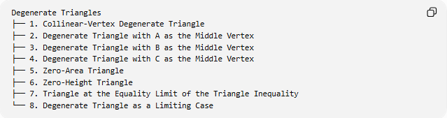
Degenerate Triangles
├── 1. Collinear-Vertex Degenerate Triangle
├── 2. Degenerate Triangle with A as the Middle Vertex
├── 3. Degenerate Triangle with B as the Middle Vertex
├── 4. Degenerate Triangle with C as the Middle Vertex
├── 5. Zero-Area Triangle
├── 6. Zero-Height Triangle
├── 7. Triangle at the Equality Limit of the Triangle Inequality
└── 8. Degenerate Triangle as a Limiting Case
The first four describe the collinear arrangement; items 5–8 describe related properties or ways the degeneracy arises. They are not eight mutually exclusive mathematical types.

Collinear-Vertex Degenerate Triangle
# Source: AI Source: Provided by: [Data Path: Persons Table -> ID Column: 1, Name_En Column: Motasem Essam] -> From: [ChatGPT] on [7/25/2026]
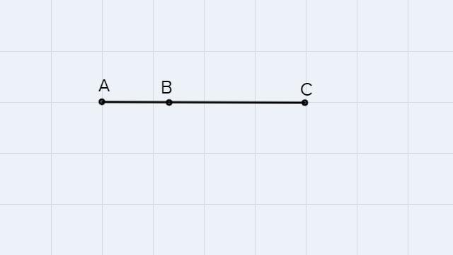
Definition: A degenerate triangle whose three distinct vertices lie on the same straight line.
If $B$lies between $A$and $C$, then:
$$\boxed{AB+BC=AC}$$
Example:
$$AB=4, BC=6, AC=10$$
Since:
$$4+6=10$$
the points can form a degenerate triangle.
Its area is:
$$\boxed{K=0}$$
This is the defining geometric configuration for the usual degenerate triangle with three distinct collinear vertices.

Degenerate Triangle with A as the Middle Vertex
# Source: AI Source: Provided by: [Data Path: Persons Table -> ID Column: 1, Name_En Column: Motasem Essam] -> From: [ChatGPT] on [7/25/2026]
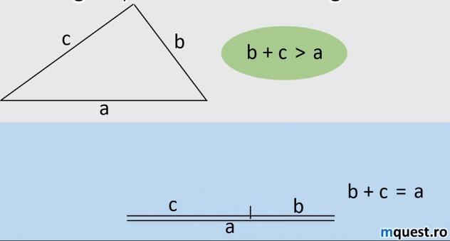
Definition: A collinear configuration in which vertex $A$lies between $B$and $C$.
The side-length relationship is:
$$\boxed{BA+AC=BC}$$
Example:
$$BA=3, AC=7, BC=10$$
Therefore:
$$3+7=10$$
The three vertices are collinear, so the area is zero.
This is a positional subtype of the same general degenerate configuration.

Degenerate Triangle with B as the Middle Vertex
# Source: AI Source: Provided by: [Data Path: Persons Table -> ID Column: 1, Name_En Column: Motasem Essam] -> From: [ChatGPT] on [7/25/2026]
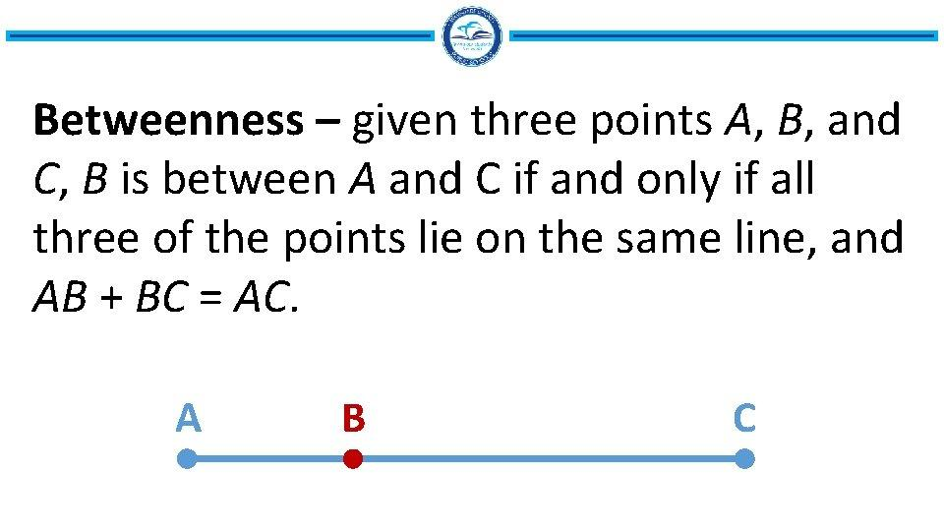
Definition: A collinear configuration in which $B$lies between $A$and $C$.
The relationship is:
$$\boxed{AB+BC=AC}$$
Example:
$$AB=5, BC=2, AC=7$$
Since:
$$5+2=7$$
the configuration is degenerate.
Again, its area is zero.

Degenerate Triangle with C as the Middle Vertex
# Source: AI Source: Provided by: [Data Path: Persons Table -> ID Column: 1, Name_En Column: Motasem Essam] -> From: [ChatGPT] on [7/25/2026]
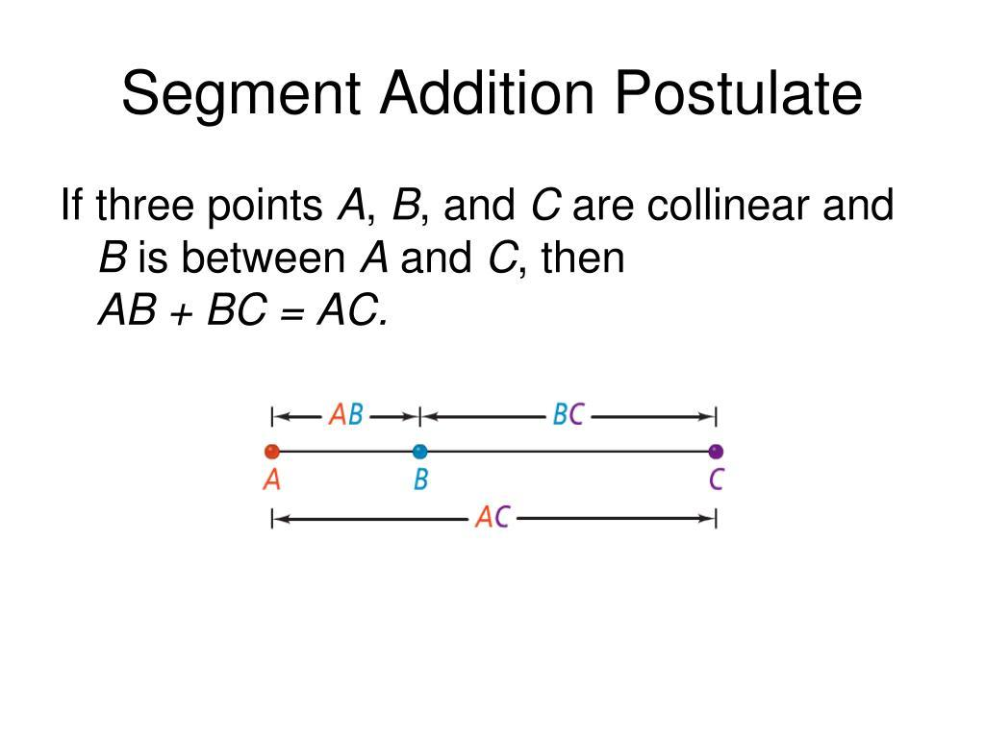
Definition: A collinear configuration in which $C$lies between $A$and $B$.
The relationship is:
$$\boxed{AC+CB=AB}$$
Example:
$$AC=4, CB=4, AB=8$$
Then:
$$4+4=8$$
The points form a degenerate triangle.
Important: These three middle-vertex arrangements are equivalent descriptions of the same general configuration, depending on which vertex lies between the other two.

Zero-Area Triangle
# Source: AI Source: Provided by: [Data Path: Persons Table -> ID Column: 1, Name_En Column: Motasem Essam] -> From: [ChatGPT] on [7/25/2026]
Definition: A triangle configuration whose area is zero because its vertices are collinear.
For a triangle with base $b$and corresponding height $h$:
$$K=\frac{1}{2}bh$$
If:
$$h=0$$
then:
$$\boxed{K=0}$$
Example:
Suppose the base is $12$units and all three vertices lie on the base line.
$$K=\frac{1}{2}\left(12\right)\left(0\right)=0$$
A zero-area configuration is a characteristic of a degenerate triangle.

Zero-Height Triangle
# Source: AI Source: Provided by: [Data Path: Persons Table -> ID Column: 1, Name_En Column: Motasem Essam] -> From: [ChatGPT] on [7/25/2026]
Definition: A degenerate triangle whose altitude to its longest side is zero.
For a non-degenerate triangle, the altitude is positive. In the degenerate case, the third vertex lies on the line containing the base, so the perpendicular height is zero.
Example:
Let:
$$AB=3, BC=4, AC=7$$
With $B$between $A$and $C$, the altitude from $B$to line $AC$is:
$$\boxed{h_{B}=0}$$
Consequently:
$$K=\frac{1}{2}\left(7\right)\left(0\right)=0$$

Triangle at the Equality Limit of the Triangle Inequality
# Source: AI Source: Provided by: [Data Path: Persons Table -> ID Column: 1, Name_En Column: Motasem Essam] -> From: [ChatGPT] on [7/25/2026]
For an ordinary triangle with side lengths $a$, $b$, and $c$, the strict triangle inequalities must hold:
$$a+b>c$$
$$a+c>b$$
$$b+c>a$$
A degenerate triangle occurs at the equality limit:
$$\boxed{a+b=c}$$
where $c$is the longest side.
Example:
$$a=6, b=8, c=14$$
Since:
$$6+8=14$$
these lengths do not form a proper triangle. They form a degenerate triangle when arranged collinearly.
If the longest side were shorter than the sum of the other two, a non-degenerate triangle could be possible, provided all three strict inequalities held.

Degenerate Triangle as a Limiting Case
# Source: AI Source: Provided by: [Data Path: Persons Table -> ID Column: 1, Name_En Column: Motasem Essam] -> From: [ChatGPT] on [7/25/2026]
Definition: A degenerate triangle can be understood as the limit of a sequence of ordinary triangles as one vertex approaches the line through the other two vertices.
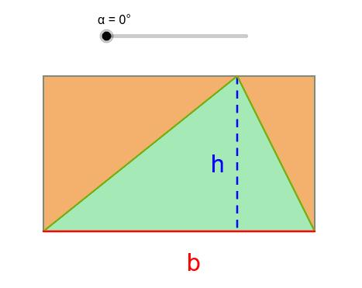
Example:
Imagine a triangle with a fixed base of length $10$and an altitude that decreases:
$$h=4, h=2, h=1, h→0$$
Its area is:
$$K=\frac{1}{2}\left(10\right)h=5h$$
As $h→0$:
$$\boxed{K→0}$$
The triangle approaches a degenerate configuration.

Mathematical Conditions for Degeneracy
# Source: AI Source: Provided by: [Data Path: Persons Table -> ID Column: 1, Name_En Column: Motasem Essam] -> From: [ChatGPT] on [7/25/2026]
A triangle with side lengths $a,b,c$is degenerate when the longest side equals the sum of the other two:
$$\boxed{c=a+b}$$
assuming $c$is the longest side.
Coordinate condition
For points $A=\left(x_{1} , y_{1}\right)$, $B=\left(x_{2} , y_{2}\right)$, and $C=\left(x_{3} , y_{3}\right)$, collinearity holds if:
$$\boxed{\left(x_{2}-x_{1}\right)\left(y_{3}-y_{1}\right)-\left(y_{2}-y_{1}\right)\left(x_{3}-x_{1}\right)=0}$$
This determinant condition means the triangle's signed area is zero.
Area condition
Using coordinates:
$$K=\frac{1}{2}∣\left(x_{2}-x_{1}\right)\left(y_{3}-y_{1}\right)-\left(y_{2}-y_{1}\right)\left(x_{3}-x_{1}\right)∣$$
Therefore:
$$\boxed{K=0}$$
is equivalent to collinearity.
Heron's formula
For side lengths $a,b,c$, define the semiperimeter:
$$s=\frac{a+b+c}{2}$$
The area is:
$$K=\sqrt{s\left(s-a\right)\left(s-b\right)\left(s-c\right)}$$
If $c=a+b$, then $s=c$, so:
$$s-c=0$$
and consequently:
$$\boxed{K=0}$$

Degenerate Triangle vs. Non-Degenerate Triangle
# Source: AI Source: Provided by: [Data Path: Persons Table -> ID Column: 1, Name_En Column: Motasem Essam] -> From: [ChatGPT] on [7/25/2026]
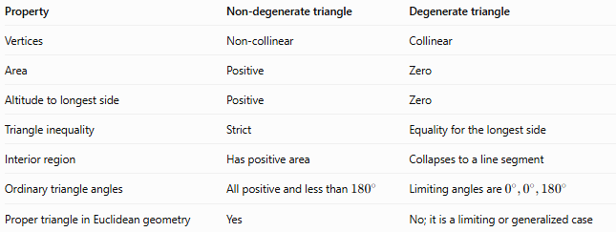
Property | Non-degenerate triangle | Degenerate triangle
Vertices | Non-collinear | Collinear
Area | Positive | Zero
Altitude to longest side | Positive | Zero
Triangle inequality | Strict | Equality for the longest side
Interior region | Has positive area | Collapses to a line segment
Ordinary triangle angles | All positive and less than ${180}^{∘}$ | Limiting angles are $0^{∘},0^{∘},{180}^{∘}$
Proper triangle in Euclidean geometry | Yes | No; it is a limiting or generalized case

Important Relationships
# Source: AI Source: Provided by: [Data Path: Persons Table -> ID Column: 1, Name_En Column: Motasem Essam] -> From: [ChatGPT] on [7/25/2026]
- Triangle Inequality: Degeneracy occurs when the longest side equals the sum of the other two.
- Collinearity: The three vertices lie on a single straight line.
- Area: The area is zero.
- Altitude: The height relative to the longest side is zero.
- Heron's Formula: Produces zero area at the equality limit.
- Limiting Geometry: An ordinary triangle can approach degeneracy as its altitude tends to zero.

Key Points
# Source: AI Source: Provided by: [Data Path: Persons Table -> ID Column: 1, Name_En Column: Motasem Essam] -> From: [ChatGPT] on [7/25/2026]
- A degenerate triangle is not a proper triangle under the usual Euclidean definition.
- Its three vertices lie on one straight line.
- Its area is zero.
- The longest side equals the sum of the other two sides.
- The three possible choices of middle vertex describe the same general configuration.
- A triangle with one side longer than the sum of the other two is impossible, not degenerate.
- If two vertices coincide, a more singular degenerate configuration may result, but that is not the standard case of three distinct collinear vertices.

Conclusion
# Source: AI Source: Provided by: [Data Path: Persons Table -> ID Column: 1, Name_En Column: Motasem Essam] -> From: [ChatGPT] on [7/25/2026]
A Degenerate Triangle is a limiting or generalized triangular configuration in which the vertices become collinear and the area collapses to zero.
Its central condition is:
$$\boxed{a+b=c}$$
where $c$is the longest side.
In ordinary Euclidean geometry, a proper triangle requires:
$$\boxed{a+b>c, a+c>b, b+c>a}$$
Equality marks the degenerate boundary between possible triangle side lengths and impossible ones.

